**Problem Statement 7: Brownie Points Task : TinkerCad**

Studio uses a combination of 2 lights – Yellow and White , which are to be controlled individually depending on the light outside Or Knobs The lights are further needed to be controlled and a balance has to be made between yellow and white light.

## Solution →

Step 1 – Circuit Diagram

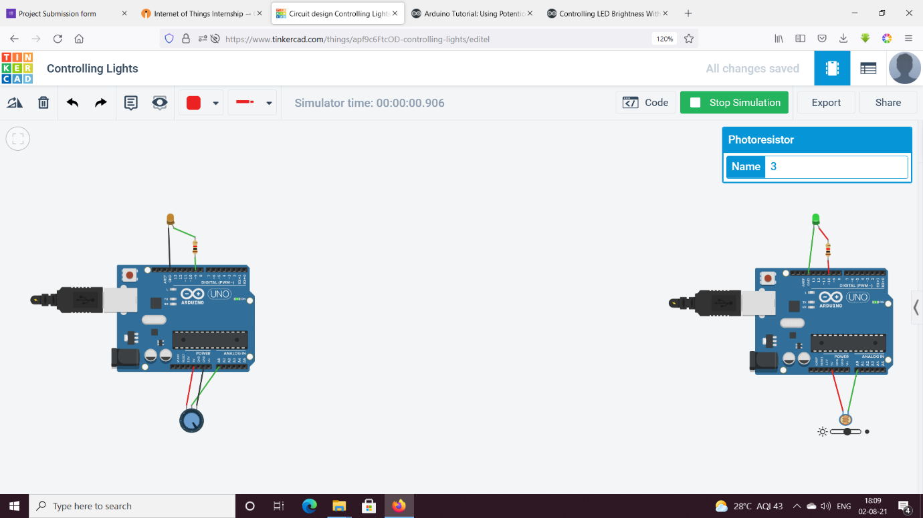

Step 2 – Code

// C++ code

int LED_pin = 10;

int readValue = 0;

int ledValue = 0;

void setup()

{

pinMode(LED_pin,OUTPUT);

}

void loop()

{

readValue = analogRead(A0);

ledValue = map(readValue,0,1024,0,255);

analogWrite(LED_pin,ledValue);

}